Chapter 7, Solution 8.

- 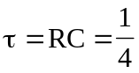
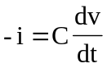
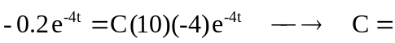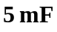
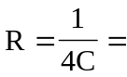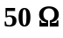
- 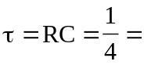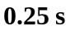
- 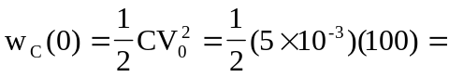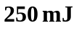
- 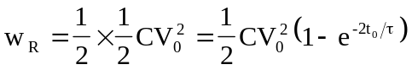
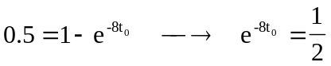
or 